**Name: Atharv Anant Borse**

**College Name: Sandip Institute of Technology and research center**

**Branch: Computer Science**

**Duration: (**20th July 2022 – 29th August 2022)

**EMAIL ID :** [**atharvaborse30@gmail.com**](mailto:atharvaborse30@gmail.com)

**Contact no - 9518740422**

**AWS cloud computing Internship**

**Team No - 48**

**Solving the Global Hiring Challenge through AWS Cloud services.**

**Project Description**:

This Project states to solve the Global Hiring Challenge with the help of Different AWS Cloud Services. The project will help in efficiently match the right profile of the candidate to the appropriate Job Title and description. The Employer and the Employee both will be located from all around the world and with the help of Global Distribution Service they both will authenticate and authorize their credentials in the Amazon Cognito service. Their information will be stored in the Amazon Relational Database (RDS) and Amazon Dynamo DB.

When the Employer will post the Job Position automatically the Lambda service will trigger and with the help of Simple Notification Service (SNS) the candidate will get the notification in his mail that the new matching job has been posted and your skills are matching so you can apply and there are __ percentage chances to get interviewed.

**Technologies used -**

**Web Development Tools:**

**Front-end:** HTML, CSS, JavaScript

HTML, the language that gives web content structure and meaning

CSS, the language used to style web pages

JavaScript, the scripting language used to create dynamic functionality on the web

**Backend:** Node.js, Express.js

Node.js is a JavaScript runtime

Express is a minimal and flexible Node.js web application framework that provides a robust set of features for web and mobile applications.

**AWS Cloud Services used and the working explained in detail -**

Cloud Platform for hosting the website: AWS (Amazon Web Services) EC2 :

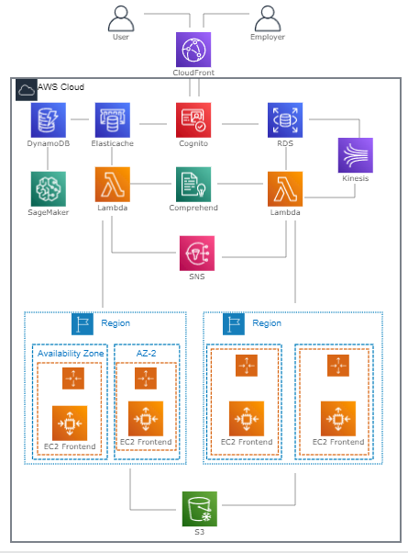

We are using AWS EC2 for the Website hosting and on top of this only our instance will be launched into the AWS account. EC2 is a good service to get the Virtual machine with high Availability and Scalability on AWS cloud.

**Step-by-Step workflow for building the solution of global hiring with job matching using AWS services:**

Step 1: User Onboarding and Profile Creation

User signs up or logs in using Amazon Cognito for authentication.

User's profile information, including skills and qualifications, is stored in Amazon RDS.

Step 2: Job Listing Creation

Employers create job listings with required skills and qualifications.

Job listings are stored in Amazon RDS, along with other job details.

Step 3: Matching Process

When a new job listing is created, an Amazon Lambda function is triggered.

Amazon Comprehend analyzes the job description to extract required skills.

The Lambda function compares required skills with user profiles stored in Amazon RDS.

Suitable candidates are identified and stored in a temporary cache.

Step 4: Job Recommendations

Amazon Machine Learning models process user profiles and past interactions.

Personalized job recommendations are generated based on the user's skills and preferences.

Step 5: Job Search and Application

Users can search for jobs based on their skills and preferences.

The frontend sends search requests to the backend.

The backend retrieves relevant job listings from Amazon RDS based on search criteria.

Users can view job details and apply directly through the platform.

Step 6: User Notifications

Amazon SNS sends notifications to users when new job matches are found.

Users receive real-time notifications about potential job opportunities.

Step 7: Application Review and Communication

Employers review job applications through the platform.

Communication between employers and job seekers is facilitated through the platform.

Step 8: Content Delivery and User Interface

Frontend resources, including static assets, are stored in Amazon S3.

Amazon CloudFront is used for fast content delivery to users across the globe.

Step 9: Monitoring and Analytics

Amazon CloudWatch monitors system performance and logs.

Analytics tools provide insights into user engagement, job matching effectiveness, and platform usage.

Step 10: Scaling and Optimization

As user base grows, Amazon EC2 instances can be scaled horizontally to handle increased traffic.

Regular optimization and improvements based on analytics insights enhance the user experience.

Benefits:

Efficient Matching: Skill-based matching improves the relevance of job opportunities for users.

Personalization: Machine learning-driven recommendations enhance user engagement.

Real-time Notifications: SNS notifications keep users informed about relevant job openings.

Scalability: AWS services allow the platform to scale according to user demands.

Global Accessibility: CloudFront ensures fast and reliable access from various locations.

Please note that the actual implementation might involve configuring various AWS services, writing code, and setting up proper integrations. This is a high-level overview, and you'd need to work with a development team to implement this workflow effectively.

**Conclusion :**

**So we are trying to solve -**

Efficient job matching based on skills and qualifications.

Personalized job recommendations enhance user experience.

Scalable architecture allows handling a global user base.

Real-time notifications keep users informed about job opportunities.

Secure authentication and authorization protect user data.

Remember that this is a high-level overview, and actual implementation might involve additional components, services, and considerations.

**Future Scope:**

We can make the Global Hiring as Automated Process with the help of Integrating AWS Cloud services and Artificial Intelligence technology where direct job profile matching and direct hiring will be done with the right job match.